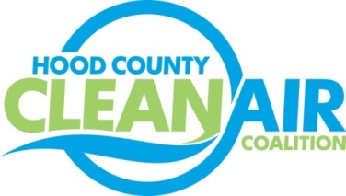
Meeting: Tuesday, December 3, 2013
American Town Hall
220 N. Travis Street, Granbury, Texas 76048
10:00-11:00 a.m.

Agenda

- Call Meeting to Order
- Updates - Michelle McKenzie
  - Green Apple School Poster Contest
  - Natural Gas Workshop
  - Air North Texas Meeting
  - Rider 8 Status
- Regional Air Quality Update – Chris Klaus
  - Air Quality Technical Meeting Follow Up
  - End of Ozone Season Summary
  - Air Quality Brainstorming Ideas
- Discussion
- Adjourn

